MECHANICAL SHOCK TEST SYSTEM
INQUIRY FORM

I.Test product specs:

- Test product name：

- Test product dia： （L*W*H）

- Single test product weight： （kg)

- Product Qty per test：

- A fixture required or not ：

- Fixture dia：

Note: The appropriate platform size can be determined according to the specs provided above. If the customer has a fixture requirement, our company can provide fixture design and production services.

II. Test conditions：

- Waveform selection：□half sine wave □saw-tooth wave □square wave

- Test standard number： （Applicable standards）

- Acceleration value：

- Pulse duration：

- Max. drop height：

- Other request：

III.Product photo：

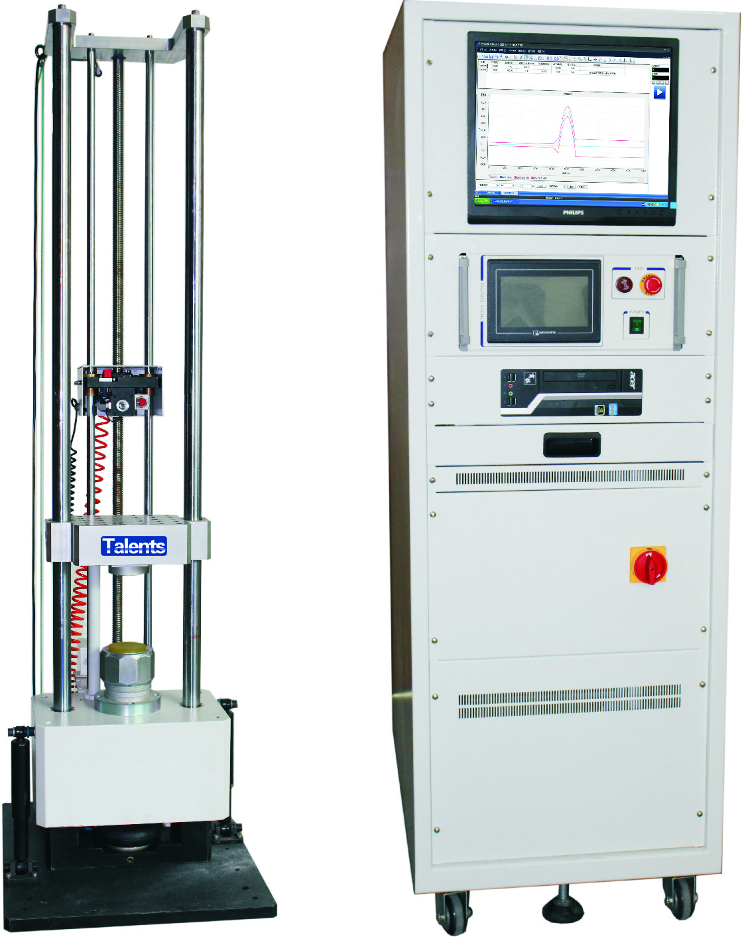

Our company has all kinds of mechanics, temperature, weather resistance reliability test equipment such as triaxial acceleration drop measurement system, zero height drop test machine, portable drop test machine, etc. for customers to choose from, Welcome to contact us.

