TEMPERATURE AND HUMIDITY CHAMBER/WALK-IN TEMPERATURE AND HUMIDITY CHAMBER INQUIRY FORM
- Inner box dia：

□ 40×40×50 □ 50×50×60 □ 60×50×75 □ 80×60×85

□ 100×80×100 □ 100×100×100 □ 150×100×100

□ other dia： （W）× （D）× （H）cm

Note: The above dimensions are width (W) × depth (D) × height (H)

- Cooling method：□ Air cooling □ Water cooling

- Temp range：low temp high temp ℃

- Hum range：low hum high hum %RH（Do not fill in this item if humidity is not required）

- Heating rate： ℃/Min. £ Linear □ Non-linear

- Cooling rate： ℃/Min □ Linear □ Non-linear

- Test product dia： （W）× （D）× （H）㎝

- Test product QTY： 。

- Test product material： 。

- Whether the product is powered：□Yes □ No

- Product test load：□ Heat load W；□Cold load ㎏。

- Other request： 。

13.Product photo of temperature and humidity chamber：

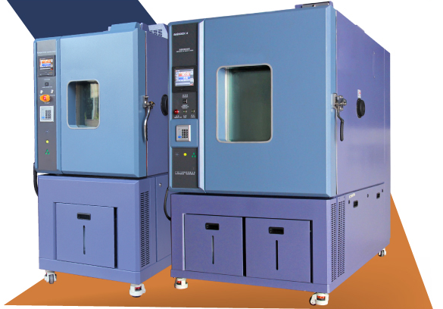

14.Product photo of walk-in temperature and humidity chamber

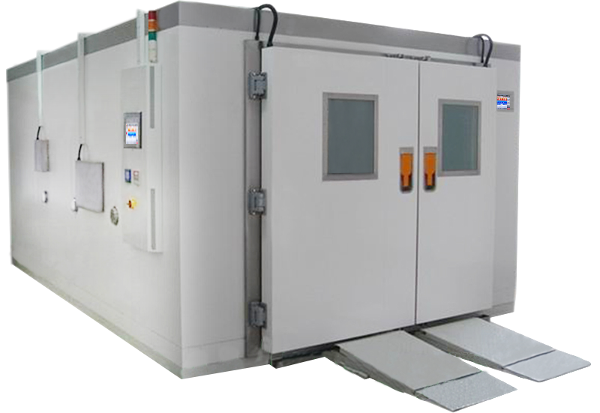

Our company is mainly engaged in various temperature, mechanics, and weather resistance reliability test equipment for customers to choose from. Welcome to contact us.

